Performance Endurance Training NC500 Charity Virtual Challenge

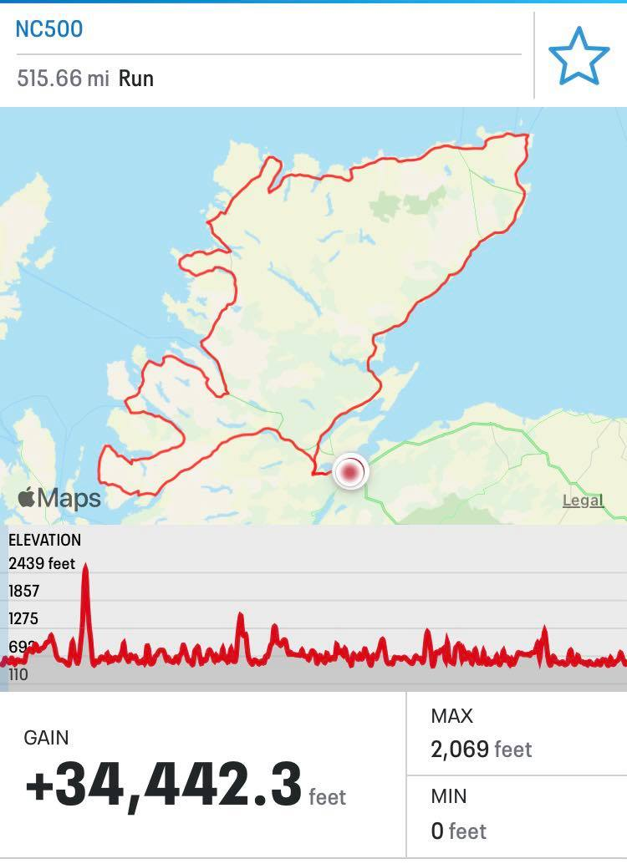
Performance Endurance Training (PET) has organised a virtual challenge set around the North Coast 500 in Scotland which is 515 miles long with 10,498m of climb. The challenge if you accept it is to run/walk your way as a team around the route which is divided into 42 stages of varying lengths from 2.6miles to 21.3miles.

This challenge is predominantly being organised to raise funds for SAMH; Scotland’s largest mental health charity - https://www.samh.org.uk/ Mental health difficulties affect one in four people in any one year and our current situation has heightened the challenges for many people. With this challenge there are no prizes for the winning teams just lots of kudos and that warm fuzzy feeling you get from doing something good with likeminded people. If you want a medal buy one, knit one or get out the paper mache.

Runners will have the chance to get together (virtually) in a team and organise themselves to complete the 42 stages in the shortest overall time. A league table for each stage and overall times for teams will be provided as the results come in.

All team details and results will be posted on the P.E.T. fb page where teams can also update everyone on their progress, submit photos of views as they make their way virtually around the NC500, connect with other teams and generally support each other. So get yourself onto my fb page while you co-opt, bully or bride other runners to make up a team - https://www.facebook.com/performanceendurancetraining

Challenge dates:
Teams will have 7 days to complete the challenge between 0500hrs Monday 12 April to 2000hrs Sunday 18 April 2021.

Teams:
Each team will be made up of between 5 - 10 members; all team members must be aged 18 and over. Each team need allocate a Team Leader who is responsible for entering their team, co-ordinating the allocation and completion of each stage, submitting results and most importantly agreeing a team name; kudos for the most outlandish and young person friendly names.

Entries:
All challenge details are on my website under the training camps / events tab - https://www.performance-endurance-training.co.uk/ Your Team Leader should complete the entry form for all members and submit it to the e-mail address provided. Entries close on the 1st April.

Challenge donation:
The donation for participating in the challenge is recommended to be £100 per team which is your payment for participation in the challenge. 100% of monies are going direct to the SAMH charity. Teams are encouraged to raise additional money if you want to. The donation of £100 must be paid at time of registering your team and please use your team name within your name or the message so that I can track all donation. This should be done by the Team Leader direct into the following Justgiving page - https://www.justgiving.com/fundraising/pet-nc500
If you are raising additional charity donations, please provide the justgiving link so that all funds can go directly to SAMH.

Stages:
Each stage must be completed in one single run/walk by a team member and the time recorded for that stage.
Remember to play to your team’s strengths when you divide up the 42 stages; they can be completed in any order as long as they are all completed within the week. You should have members who are able to pitch in to take over stages if a runner is unable to complete all their stages. There is no need to declare what stages you are doing at time of entry so you can move these about within your team.
There are 16 stages over HM distance and they should be undertaken by experienced longer distance members of your team.

Safety:
All team members are responsible for the safety of their team and they should be aware of when a team member is covering a stage and that they have completed it safely; this could be done through the likes of a Whatsapp group, phone trackers and/or buddy runner approach. Please choose your run routes carefully and avoid routes with traffic or on higher ground if inexperienced.

Results:
Although this is a challenge, we all know how competitive runners can be so results will be made available. Team Leaders must submit all results to the P.E.T. e-mail by 2100hrs on Sunday 18 April, or confess if they are going to be late. Results will be provided both for individual stages and for each team’s complete run time around the NC500. Results will be published on the P.E.T. facebook page and website, as soon after the event as possible.

To assist me to do this, ongoing results from teams would be welcome. All results should be sent in on the results excel (to be found on the website) with team members name and time as hr:min:sec, eg 01:45:34.

Challenge guidelines for running and recording each stage:
- All runs must be equal to or just over the actual distance of the stage. No I will not be rounding them down if you run too far!
- All runs must be recorded on strava or garmin, or alternative suitable devices in miles. A screenshot for each stage must be included with the results e-mail sent by your Team Leader. Screenshots should include the elapsed time (not moving time), distance in miles, date, your name and elevation – see examples below.
- All runs must have a positive gain on climb over the total distance, although there is no requirement to match the actual geographical climb of your stage.

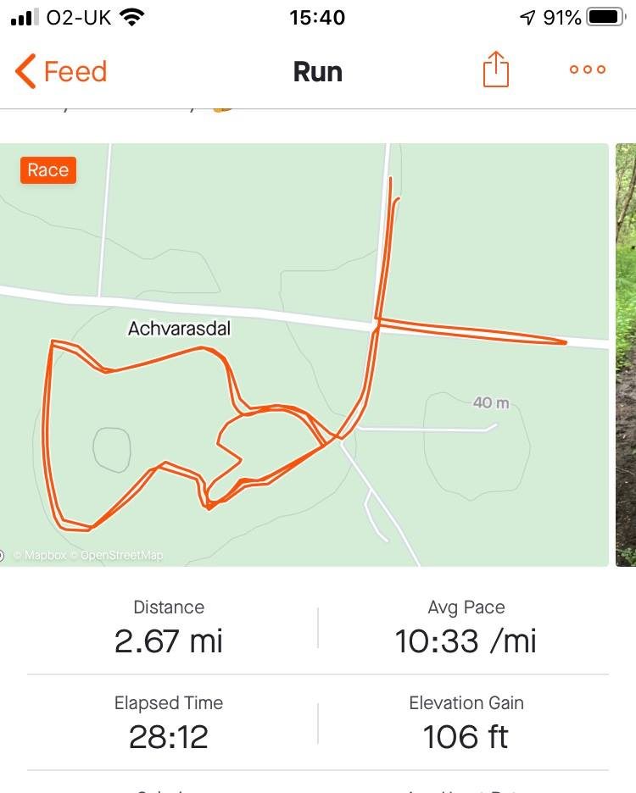
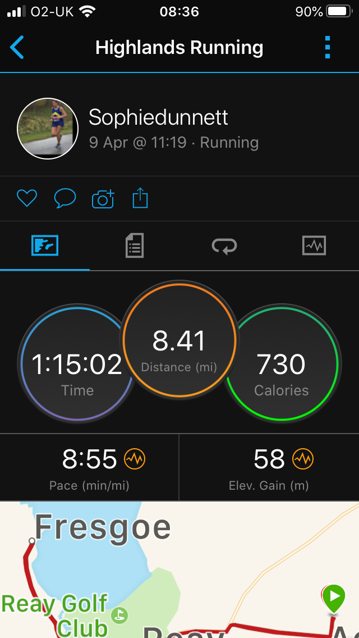
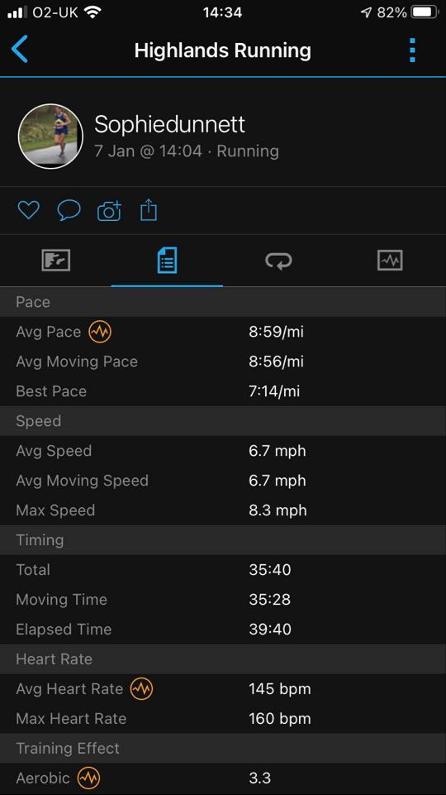

Stages:

Start | Finish | Distance (miles)
Inverness Castle | Beauly | 12.5
Beauly | Marybank | 6.6
Marybank | Garve | 8.6
Garve | Achnasheen | 16
Achnasheen | Lochcarron | 21.3
Lochcarron | Applecross | 17
Applecross | Fearnmore | 13
Fearnmore | Torridon | 19.4
Torridon | Kinlochewe | 10.6
Kinlochewe | Gairloch | 19.9
Gairloch | Poolewe | 5.6
Poolewe | Mungasdale | 16
Mungasdale | Dundonnall | 8.8
Dundonnall | Braemore | 16
Braemore | Ullapool | 11
Ullapool | Elphin | 15.1
Elphin | Little Assynt | 17
Little Assynt | Stoer | 9.7
Stoer | Kylesku | 18.2
Kylesku | Laxford Bridge | 16.4
Laxford Bridge | Rhiconich | 4.6
Rhiconich | Durness | 14.1
Durness | Eriboll | 15
Eriboll | Tongue | 14
Tongue | Bettyhill | 13
Bettyhill | Melvich | 13
Melvich | Thurso | 17.1
Thurso | Dunnet | 8.5
Dunnet | John O’Groats | 11.1
John O’Groats | Wick | 16.4
Wick | Latheron | 16.6
Latheron | Berriedale | 9.7
Berriedale | Helmsdale | 8.8
Helmsdale | Brora | 11.4
Brora | Golspie | 5.7
Golspie | Evelix, Dornoch | 9.8
Evelix, Dornoch | Knockbreck, Tain | 8.8
Knockbreck, Tain | Dalmore, Alness | 12.9
Dalmore, Alness | Dingwall | 10.7
Dingwall | Muir of Ord | 6.1
Muir of Ord | Beauly | 2.6
Beauly | Inverness Castle | 12.5

Covid-19 Guidelines:
This virtual challenge is being offered subject to current Government guidelines. Please make sure you are up to speed with the current level, tier or lockdown guidelines which apply to where you are running.

Any questions please get in touch. Keep running, stay safe and many thanks in advance for your support for the NC500 Charity Virtual Challenge and SAMH.

Sophie Dunnett
Performance Endurance Training

