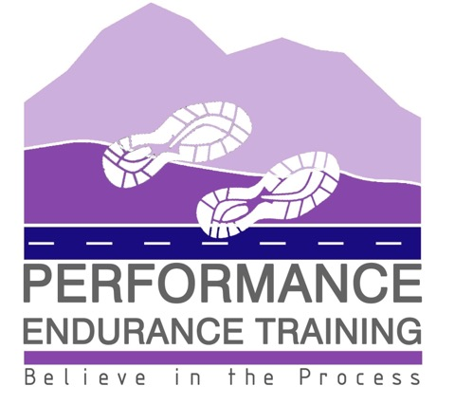

Many thanks for your interest in the Performance Endurance Squad.

Having been involved in coaching young people for many years, we are keen to offer weekly squad training sessions to two age groups:

P6-7: 4-5pm
S1-6: 5-6pm

Both sessions will take place at Scrabster Community Hall, near Thurso, starting on the 20th April. The cost is £3 per session or £12 per month to be paid online. For young people to get the most from these sessions, it is important to maintain regular attendance.

Sessions are specifically aimed at young people who have an interest in running as a sport, with the focus on everything from 800m to 5k, trail, hill and cross country running. We are also keen to work with young people who would benefit from a focus on their aerobic fitness to enhance other sports that they take part in.

For those young people who want to increase their general fitness, the fun group sessions are an ideal environment to foster a good healthy relationship with outdoor exercise whilst spending social time with peers. As part of the sessions we are keen to foster a greater understanding of the nutritional requirements when participating in sport.

The sessions will specifically focus on:
- Aerobic fitness
- Mobility and injury prevention
- Strength and conditioning
- Nutritional awareness

Sessions will be led by Sophie Dunnett, UK Athletics Level 3 Endurance Performance Coach and Oonagh Dunnett, UK Athletics Leader in Running Fitness. Both Coaches have undertaken the required Child Protection and First Aid training. Full risk assessments have been completed and can be viewed on request, and insurance cover is in place through Insure4Sport.

Young people attending should be suitably dressed, appropriate to the weather, with all sessions outdoors unless the weather conditions require us to make use of the hall. They should have a warm top, leggings/tracksuit, and a jacket that they can run in as well as shorts and teeshirts/long sleeve top. Spare trainers will be required for weeks when we go back into the hall for a strength and conditioning session.

They should take water with them for during the session but please no sports or fizzy drinks.

To book a space in the squad, please complete the google form in the following link - https://forms.gle/bhbmcTyireERqhfNA There will be a maximum of 15 spaces in each squad on a first come first serve basis. General communication in relation to the squad will be done through a parent/guardian whatsapp group.

If you have any questions in the meantime, please do not hesitate to contact us and we will either respond by e-mail or can arrange to phone and chat through anything.

Many thanks again for your interest and we look forward to hearing from you,

Sophie & Oonagh
E-mail: sophie@performance-endurance-training.co.uk
Mobile: 07756298913

