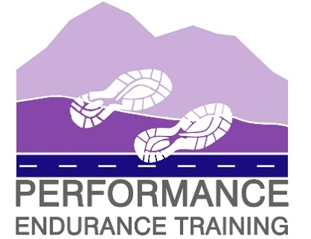 | BelieveInTheProcess
06/02/2021 | Sophie Dunnett  Performance Endurance Training  Shebster View, Blackhills,  Reay, Caithness  KW14 7RR
NC500 Charity Virtual Challenge entry form
12th-18th April 2021
Team Leader Name:…………………………………………………………………………………………………………………………….
Contact mobile number:…………………………………………………………………………..
E-mail address:…………………………………………………………………………………………………………………………..
Team Name: ……………………………………………………………………………………………………………………………………….
Team Members:
- Team Leader ……………………………………………………….. Home town…………………………………………..

- …………………………………………………………………………………….. Home town…………………………………………..

- …………………………………………………………………………………….. Home town…………………………………………..

- …………………………………………………………………………………….. Home town…………………………………………..

- …………………………………………………………………………………….. Home town…………………………………………..

- …………………………………………………………………………………….. Home town…………………………………………..

- …………………………………………………………………………………….. Home town………………………………………….

- …………………………………………………………………………………….. Home town………………………………………….

- …………………………………………………………………………………….. Home town………………………………………….

- …………………………………………………………………………………….. Home town…………………………………………..
By entering your team, you are agreeing to follow all of the guidance provided in the NC500 Charity Virtual Challenge instructions on the P.E.T. website.
Next steps:
- Return completed entry form to sophie@performance-endurance-training.co.uk. by the 1st April at the latest
- Make your team donation to https://www.justgiving.com/fundraising/pet-nc500 and include your team name in the ‘name’ or ‘message’ box. Please make sure you have checked with all members before you tick the gift aid box
- Pass the details of the Justgiving page onto your team members if they wish to raise more money for SAMH
- ‘Like’ the P.E.T. facebook page and post updates about your team and its progress for the challenge - https://www.facebook.com/performanceendurancetraining
- Complete the NC550 results sheet with the names of each team member against the stages they are running. Then log their results as they run each stage. Results sheets and screenshots should be sent to the P.E.T. e-mail address above by 2100hrs on Sunday 18th April. To prevent me having an excel meltdown please send interim results also through the week.
Any questions please get in touch. Keep running, stay safe and many thanks in advance for your support for the NC500 Charity Virtual Challenge and SAMH.
Sophie Dunnett
Performance Endurance Training
Phone: 07756 298 913
E-mail: sophie@performance-endurance-training.co.uk

